

International School

**Capstone Project 1**

CMU-SE 450/CMU-IS 450/CMU-CS450

**Project Plan**

**Version 1.0**

**Date: September 17, 2020**

**UNIVERSITY REVIEWS**

**Submitted by**

**Nguyen Van Minh Toi**

**Nguyen Huu Thien**

**Ho Xuan Sang**

**Huynh Thi Quy Thuong**

**Approved by**

**Project Plan Review Panel Representative:**

Name Signature Date

**Capstone Project 1- Mentor:**

Name Signature Date

**Dr.Ha Thi Nhu Han**

**PROJECT INFORMATION**

|  |  |  |  |
| --- | --- | --- | --- |
| **Project acronym** | URs | | |
| **Project Title** | University reviews | | |
| **Start Date** | August 13, 2020 | End Date | December 05, 2020 |
| **Lead Institution** | International School, Duy Tan University | | |
| **Project Mentor &contact details** | Dr. Ha Thi Nhu Hang  Email: [hatnhuhang@duytan.edu.vn](mailto:hatnhuhang@duytan.edu.vn)  Tel: 0707121301 | | |
| **Product Owner** | Toi, Nguyen Van Minh  Email: [minhtoi2799@gmail.com](mailto:minhtoi2799@gmail.com)  Tel: 0902257132 | | |
| **Scrum Master** | Thien, Nguyen Huu  Email: [huuthiennguyen1999@gmail.com](mailto:huuthiennguyen1999@gmail.com)  Tel: 0783533812 | | |
| **Team members** | **Name** | **Email** | **Tel** |
| Toi, Nguyen Van Minh | minhtoi2799@gmail.com | 0902257132 |
| Thien, Nguyen Huu | huuthiennguyen1999@gmail.com | 0783533812 |
| Sang, Ho Xuan | hsang19999@gmail.com | 0362982905 |
|  | Thuong, Huynh Thi Quy | quythuong0405@gmail.com | 0333633770 |

|  |  |  |  |
| --- | --- | --- | --- |
| **DOCUMENT NAME** | | | |
| **Document Title** | Project Plan Document | | |
| **Author(s)** | C1SE.04 Team | | |
| **Role** | Thien, Nguyen Huu  Toi, Nguyen Van Minh | | |
| **Date** | 17 – Sep – 2020 | **File name:** | Project plan v1.0 |
| **URL** |  | | |
| **Access** |  | | |

|  |  |  |  |
| --- | --- | --- | --- |
| **REVISION HISTORY** | | | |
| **Version** | **Person** | **Date** | **Description** |
| **1.0** | Thien, Nguyen Huu | 17 – Sep – 2020 | Draft |

|  |  |  |  |
| --- | --- | --- | --- |
| **Document Approval**  The following signatures are required for approval of this document | | | |
| **Mentor** | Dr. Ha Thi Nhu Hang | **Signature:** |  |
| **Date:** |  |
| **Signature:** |  |
| **Date:** |  |
| **Product Owner** | Nguyen Van Minh Toi | **Signature:** |  |
| **Date:** |  |
| **Scrum Master** | Nguyen Huu Thien | **Signature:** |  |
| **Date:** |  |
| **Team Member(s)** | Huynh Thi Quy Thuong | **Signature:** |  |
| **Date:** |  |
| Ho Xuan Sang | **Signature:** |  |
| **Date:** |  |

**Table of contents**

**1. Introduction: 5**

1.1. Purpose: 5

1.2. Project Overview: 5

**2. Team Organization: 5**

2.1. Scrum Team Information: 5

2.2. Role and Responsibility: 5

2.3. Communication Methodology: 7

2.4. Communication and Report: 7

**3. Development Process: 8**

**4. Schedule and Cost: 9**

4.1. Detailed Schedule: 9

4.2. Cost: 16

***4.2.1. Cost Person/Hours 16***

***4.2.2. Total Cost Estimate 16***

**5. System development environment: 17**

**6. Project Risk: 17**

**7. Work Breakdown Structure: 19**

**8. Deliverables 20**

1. Introduction:
   1. Purpose:

This document provides a summary of the project's objectives, division of work, the major milestones, required resources, time and overall schedule and budget allocation used and based on the document proposal to build a dating website application on time, at the request and plan.

* 1. Project Overview:

Reference to [URs] Proposal_C1SE.04_2020_V1.4.doc

1. Team Organization:
   1. Scrum Team Information:

***Table 1: Scrum Team Organization.***

|  |  |  |  |
| --- | --- | --- | --- |
| **Full name** | **Phone** | **Email** | **Position** |
| Hang, Ha Thi Nhu | 0707121301 | hatnhuhang@duytan.edu.vn | Mentor |
| Toi, Nguyen Van Minh | 0902257132 | minhtoi2799@gmail.com | Product Owner |
| Thien, Nguyen Huu | 0783533812 | huuthiennguyen1999@gmail.com | Scrum Master |
| Sang, Ho Xuan | 0362982905 | hsang19999@gmail.com | Member |
| Thuong, Huynh Thi Quy | 0333633770 | quythuong0405@gmail.com | Member |

* 1. Role and Responsibility:

***Table 2: Role and Responsibilities.***

|  |  |  |
| --- | --- | --- |
| **Role** | **Responsibility** | **Name/Title** |
| **Mentor** | * Guide on the process. * Monitoring all activities of Team. * Help with anything. | Hang, Ha Thi Nhu |
| **Product Owner** | * Understand the user and customers with their needs. * Collaborate with the development team. * Describe the user experience and product features. * Provides detailed user stories. | Toi, Nguyen Van Minh |
| **Scrum Master** | - Communicate the value of Scrum, teach the organization on Scrum, attend all Scrum meetings, preserve the integrity and spirit of the Scrum framework.  - Maintain the focus of the Team  - Make the Team aware of impediments and facilitate efforts to resolve them  - Continually work with the Team to find and implement improvements | Thien, Nguyen Huu |
| **Secretary** | * Record the content of group meetings and activities of the member | Thuong, Huynh Thi Quy |
| **Reviewer** | * Review documents | Thien, Nguyen Huu |
| **Developer** | * Analysis of the functions and requirements of the product. * Code and test. * Fix error. | All Members |
| **Tester** | * Do the Test plan * Creation of test designs, test processes, test cases and test data. * Carry out testing as per the defined procedures. * Graph the results and make sure people know when test results decline. * Prepare all reports related to software testing carried out. * Analysis and evaluate the Test result. * Ensure that all tested related work is carried out as per the defined standards and procedures. | Sang, Ho Xuan  Toi, Nguyen Van Minh  Thuong, Huynh Thi Quy |

* 1. Communication Methodology:

***Table 3: Communication Methodology.***

|  |  |  |  |
| --- | --- | --- | --- |
| **Audience/ Attendees** | **Topic/ Deliverable** | **Frequency** | **Method** |
| **Mentor and All team member** | Project Progress Review | Weekly | Zoom Meeting, Email, Face to face |
| **All team member** | Project Progress Review | Weekly | Zoom Meeting, Trello |
| Explicit Requirement | When needed | Email, Zoom Meeting, Facebook |
| Daily Meeting | Daily | Zoom Meeting |
| **Mentor and All team member** | Evaluate landmark | End of each landmark | Zoom Meeting, Email, Face to face |

* 1. Communication and Report:

***Table 4: Communication and Report.***

|  |  |  |  |  |
| --- | --- | --- | --- | --- |
| **Type of communication** | **Methods, tools** | **Frequency** | **Information** | **People** |
| **Communication among in group** | | | | |
| **Report (Daily Meetings)** | Zoom Meeting, or direct | Every two day | Informed about what was done in the last 24 hours, working on plans for today, the difficulties encountered and the solutions required, just meeting 10-15 minutes. | Project team |
| **Task Planning Meeting** | Meet face to face or Zoom Meeting | 15-20 days | All members of the team together to analyze the requirements, functions, working on the sprint going to do, planning, and design for the sprint. | All team member |
| **Task Review Meeting** | Meet face to face or Zoom Meeting | 15-20 days | Complete documentation. For each stage, sharing materials, given the strengths and weaknesses for each. Period for each member and the solution calculated measurement project. | All team member |
| **External communication and reporting** | | | | |
| **Task Management** | Trello, Git | When needed | A web-based task tracking system. To manage or divide tasks, report bugs/issues. | All team member |
| **Ask and evaluate problems** | Email, Zoom Meeting, Direct | When needed | Ask the mentor to answer questions during the process | Mentor and all team member |

1. Development Process:

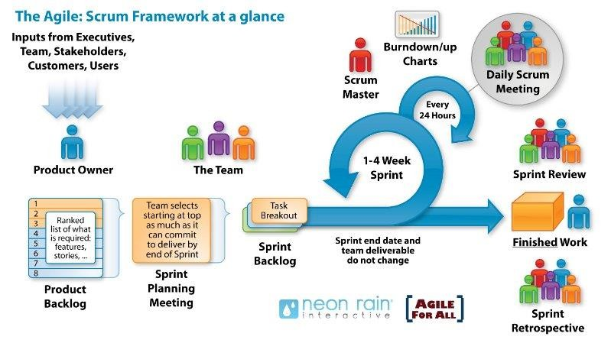**Scrum Process**

* Scrum is an iterative and incremental agile software development framework for managing software projects and product or application development.
* Scrum focuses on project management institutions where it is difficult to plan ahead.
* Mechanisms of empirical process control, where feedback loops that constitute the core management technique are used as opposed to traditional command-and-control management.
* Its approach to planning and managing projects is by bringing decision-making authority to the level of operation properties and certainties.

Benefit of the methodology:

* Project can respond easily to change.
* Problems are identified early.
* Customer gets most beneficial work first.
* Work done will better meet the customer’s needs.
* Improved productivity.
* Ability to maintain a predictable schedule for delivery.

1. Schedule and Cost:
   1. Detailed Schedule:

***Table 4: Detailed Schedule :***

|  |  |  |  |  |
| --- | --- | --- | --- | --- |
| **No.** | **Task Name** | **Start** | **Finish** | **Effort(hrs)** |
| **1** | **Initial** | **13-August-20** | **18-August-20** |  |
| **1.1** | **Gathering Requirement** | **13-August-20** | **15-August-20** | **14** |
| 1.1.1 | Project initiation meeting | 13-August-20 | 13-August-20 | 8 |
| 1.1.3 | Talk to mentor | 15-August-20 | 15-August-20 | 6 |
| **1.2** | **Create Proposal Document** | **16-August-20** | **18-August-20** | **36** |
| 1.2.1 | Product Definition | 16-August-20 | 16-August-20 | 6 |
| 1.2.2 | Business Need | 16-August-20 | 16-August-20 | 6 |
| 1.2.3 | Current Status of Art | 16-August-20 | 16-August-20 | 6 |
| 1.2.4 | Proposed Solution | 16-August-20 | 17-August-20 | 12 |
| 1.2.5 | Tasks and Deliverables | 17-August-20 | 18-August-20 | 6 |
| **2** | **Start Up** | **19-August-20** | **28- August -20** | **9** |
| 2.1 | Project kick-off | 19-August-20 | 19-August-20 | 3 |
| 2.2 | Discuss and analyze ideas | 19-August-20 | 19-August-20 | 6 |
| **2.3** | **Discuss and Create Document** | **20- August -20** | **28- August -20** | **75** |
| 2.3.1 | Create Project Plan | 20-August-20 | 28-August-20 | 9 |
| 2.3.2 | Create User Stories | 20-August-20 | 28-August-20 | 15 |
| 2.3.3 | Create Product Backlog | 20-August-20 | 28-August-20 | 15 |
| 2.3.4 | Create SRS | 20-August-20 | 28-August-20 | 15 |
| 2.3.5 | Create Architecture | 20-August-20 | 28-August-20 | 21 |
| **3** | **Development** | **29-** **August -20** | **01- December -20** |  |
| **3.1** | **Sprint 1** | 29- August -20 | 25-September-20 | **123** |
| 3.1.1 | Sprint Planning Meeting | 29- August -20 | 29- August -20 | 3 |
| 3.1.2 | Create Sprint Backlog | 29- August -20 | 31- August -20 | 9 |
| 3.1.3 | Create Test Plan document | 19-September-20 | 20-September-20 | 3 |
| **3.1.5** | **Design UI** | **01-September-20** | **06-September-20** | **33** |
| 3.1.5.2 | Analysis architecture of UI administrator and User | 01-September-20 | 03-September-20 | 9 |
| 3.1.5.2 | Design basic UI of User : PB1, PB2, PB4, PB6 | 03-September-20 | 06-September-20 | 12 |
| 3.1.5.3 | Design basic UI of Administrator: PB38, PB40, PB41 | 03-September-20 | 06-September-20 | 12 |
| **3.1.6** | **Functional development** | **07-September-20** | **14-September-20** | **21 hrs** |
| 3.1.6.1 | Code functions and interface which were listed on item No 3.1.5 | 07-September-20 | 11-September-20 | 15 |
| 3.1.6.2 | Make Test Plan Document for Sprint 1 | 12-September-20 | 14-September-20 | 6 |
| **3.1.7** | **Test function** | **15-September-20** | **18-September-20** | **24** |
| 3.1.7.1 | Design test case interface Collection | 15-September-20 | 16-September-20 | 12 |
| 3.1.7.2 | Design test case for functions listed on item No 3.1.6 | 16-September-20 | 18-September-20 | 12 |
| **3.1.8** | **Fix bug and re-testing** | **19-September-20** | **23-September-20** | **24** |
| 3.1.8.1 | Fix bugs design User, Administrator UI and UX | 19-September-20 | 21-September-20 | 9 |
| 3.1.8.2 | Fix bugs about function on sprint 1 | 20-September-20 | 22-September-20 | 9 |
| 3.1.8.3 | Re-testing all of functions and design within sprint 1 | 23-September-20 | 23-September-20 | 6 |
| **3.1.9** | **Release Sprint 1** | **24-September-20** | **25-September-20** | **6** |
| 3.1.9.1 | Sprint 1 Review Meeting | 24-September-20 | 24-September-20 | 3 |
| 3.1.9.2 | Sprint 1 Retrospective | 25-September-20 | 25-September-20 | 3 |
| **3.2** | **Sprint 2** | 25-September-20 | 22-October-20 | **132** |
| 3.2.1 | Sprint Planning Meeting | 25-September-20 | 25-September-20 | 3 |
| 3.2.2 | Create Sprint Backlog | 26-September-20 | 27-September-20 | 9 |
| 3.2.3 | Create Test Plan document for sprint 2 | 26-September-20 | 27-September-20 | 3 |
| **3.2.4** | **Design UI and structure database** | **27-September-20** | **30-September-20** | **24** |
| 3.2.4.1 | Make detail page for User and administrator | 27-September-20 | 29-September-20 | 12 |
| 3.2.4.2 | Design database table for topic and university content | 27-September-20 | 31-September-20 | 12 |
| **3.2.5** | **Functional development** | **31-September-20** | **11-October-20** | **45** |
| 3.2.5.1 | Code frame interface which were listed on item “Design UI” | 31-September-20 | 02-October-20 | 9 |
| 3.2.5.2 | Code function “view university information” | 03-October-20 | 04-October-20 | 12 |
| 3.2.5.3 | Code function “search and filter” | 05-October-20 | 08-October-20 | 12 |
| 3.2.5.4 | Code “interactive functions in the topic” | 09-October-20 | 11-October-20 | 12 |
| **3.2.6** | **Test function** | **12-** **October -20** | **16-** **October -20** | **12** |
| 3.2.5.1 | Design test case for functions which were listed item No 3.2.5 | 12- October -20 | 14- October -20 | 6 |
| 3.2.6.2 | Design test case for UX, UI | 14- October -20 | 16- October -20 | 6 |
| **3.2.7** | **Fix bug & re-testing** | **16-** **October -20** | **20-** **October -20** | **30** |
| 3.2.7.1 | Fix all of bugs in phase “ testing” | 16- October -20 | 18- October -20 | 15 |
| 3.2.7.2 | Re-testing | 18- October -20 | 19- October -20 | 15 |
| **3.2.8** | **Release Sprint 2** | **20- October -20** | **22- October -20** | **6** |
| 3.2.8.1 | Sprint 2 Review Meeting | 20- October -20 | 20- October -20 | 3 |
| 3.2.8.2 | Sprint 2 Retrospective | 21- October -20 | 22- October -20 | 3 |
| **3.3** | **Sprint 3** | **22- October -20** | **11- November 20** | **108** |
| 3.3.1 | Sprint Planning Meeting | 22- October -20 | 22- October -20 | 3 |
| 3.3.2 | Create Sprint Backlog | 23- October -20 | 24- October -20 | 6 |
| 3.3.3 | Create Test Plan document for sprint 3 | 23- October -20 | 24- October -20 | 3 |
| **3.3.4** | **Design UI and Database** | **25- October -20** | **28- October -20** | **18** |
| 3.3.4.1 | Design database for manage account user | 25- October -20 | 27- October -20 | 9 |
| 3.3.4.2 | Design UI and UX for “university” actor | 25- October -20 | 28- October -20 | 9 |
| **3.3.5** | **Functional development** | **28- October -20** | **03- November-20** | **36** |
| 3.3.5.1 | Code function “view interaction” for university | 28- October -20 | 30- October -20 | 12 |
| 3.3.5.2 | Code function “ create articles” for university | 30- October -20 | 01- November-20 | 12 |
| 3.3.5.3 | Code UI for university actor | 01- November-20 | 03- November-20 | 12 |
| **3.3.6** | **Test function** | **04- November-20** | **06- November-20** | **12** |
| 3.3.6.1 | Design test case for functions which were listed item No 3.2.5 | 04- November-20 | 05- November-20 | 6 |
| 3.3.6.2 | Design test case for UX, UI | 04- November-20 | 06- November-20 | 6 |
| **3.3.7** | **Fix bug & re-testing** | **06- November-20** | **09- November-20** | **24** |
| 3.3.7.1 | Fix all of bugs in phase “ testing” | 06- November-20 | 08- November-20 | 18 |
| 3.3.7.2 | Re-testing | 08- November-20 | 09- November-20 | 6 |
| **3.3.8** | **Release Sprint 3** | **10-November-20** | **11- November-20** | **6** |
| 3.3.8.1 | Sprint 3 Review Meeting | 10- November-20 | 10- November-20 | 3 |
| 3.3.8.2 | Sprint 3 Retrospective | 11- November-20 | 11- November-20 | 3 |
| **3.4** | **Sprint 4** | **11- November-20** | **01- December -20** |  |
| 3.4.1 | Sprint Planning Meeting | 11- November-20 | 11- November-20 | 3 |
| 3.4.2 | Create Sprint Backlog | 12- November-20 | 12- November-20 | 6 |
| 3.4.3 | Create Test Plan document for sprint 4 | 12- November-20 | 12- November-20 | 3 |
| **3.4.4** | **Design UI** | **13- November-20** | **16- November-20** | **18** |
| 3.4.4.1 | Design side effect UX | 13- November-20 | 15- November-20 | **9** |
| 3.4.4.2 | Design effect interface | 15- November-20 | 16- November-20 | 9 |
| **3.4.5** | **Functional development** | **17- November-20** | **24- November-20** | **48** |
| 3.4.5.1 | Code UI which were listed in No 3.3.4 | 17- November-20 | 19- November-20 | 12 |
| 3.4.5.2 | Code side function “ forgot password, change password” | 20- November-20 | 22- November-20 | 12 |
| 3.4.5.3 | Code function “Edit account information” | 20- November-20 | 22- November-20 | 12 |
| 3.4.5.4 | Code “Notification” functions | 22- November-20 | 24- November-20 | 12 |
| **3.4.6** | **Test function** | **25- November-20** | **27- November-20** | **24** |
| 3.4.6.1 | Design test case for functions which were listed item No 3.2.5 | 25- November-20 | 27- November-20 | 12 |
| 3.4.6.2 | Design test case for UX, UI | 25- November-20 | 27- November-20 | 12 |
| **3.4.7** | **Fix bug & re-testing** | **27- November-20** | **29- November-20** | **24** |
| 3.4.7.1 | Fix all of bugs in phase “ testing” | 27- November-20 | 29- November-20 | 18 |
| 3.4.7.2 | Re-testing | 29- November-20 | 29- November-20 | 6 |
| **3.4.8** | **Release Sprint 4** | **30- November-20** | **01- December -20** | **6** |
| 3.4.8.1 | Sprint 4 Review Meeting | 30- November-20 | 30- November-20 | 3 |
| 3.4.8.2 | Sprint 4 Retrospective | 01- December -20 | 01- December -20 | 3 |
| **4** | **Project Meeting** | **01- December -20** | **02- December -20** | **6** |
| **5** | **Final Release** | **03-December-20** | **04- December -20** | **6** |
|  | **Duration** |  |  | **641 hrs** |

* 1. Cost:
     1. Cost Person/Hours

***Table 5 Cost person :***

|  |  |  |
| --- | --- | --- |
| **Full Name** | **Role** | **Salary Rate (USD/hour)** |
| Toi, Nguyen Van Minh | Product Owner, Member | 1.8 |
| Thien, Nguyen Huu | Master Scrum, Member | 1.8 |
| Thuong, Huynh Thi Quy | Member | 1.8 |
| Sang, Ho Xuan | Member | 1.8 |

* + 1. Total Cost Estimate

***Table 6: total cost Estimate :***

|  |  |  |  |  |
| --- | --- | --- | --- | --- |
| **No** | **Criteria** | **Milestone** | **Working hours(3hour/day)** | **Cost( 1.8 $/hour)** |
| **1** | **Initial** | **INI** | **72** | **$129.6** |
| **2** | **Start Up** | **STU** | **120** | **$216** |
| **3** | **Development** |  |  |  |
| 3.1 | Sprint1 | SPR1 | 336 | $604.8 |
| 3.2 | Sprint2 | SPR2 | 336 | $604.8 |
| 3.3 | Sprint3 | SPR3 | 252 | $453.6 |
| 3.4 | Sprint4 | SPR4 | 252 | $453.6 |
| **4** | **Other Cost** | **OTH** |  | **$50** |
| **5** | **Project Meeting** | **PM** | **24** | **$43.2** |
| **6.** | **Final Release** | **FR** | **36** | **$64.8** |
|  | **TOTAL** |  | 1428 | $2620.4 |

1. System development environment:

***Table 7: System development environment:***

|  |  |
| --- | --- |
| **Ingredient** | **Development environment** |
| Operating system | Window |
| Development tools | Visual code |
| Programming languages and supporting libraries | Html 5, Css, JavaScript, React JS, Redux-saga, axios. |
| CMS | Keystone JS |
| Database | noSQL (MongoDB) |

1. Project Risk:

***Table 8: Rating for likelihood and seriousness for each risk:***

|  |  |
| --- | --- |
| **Rating for Likelihood and Seriousness for each risk** | |
| **L** | Rated as Low |
| **M** | Rated as Medium |
| **H** | Rated as High |
| **E** | Rated as Extreme (Used for Seriousness only) |
| **NA** | Not Assessed |

***Table 9: Project Risk.***

|  |  |  |  |  |
| --- | --- | --- | --- | --- |
| **Risk** | **Definition** | **Level** | **Likelihood** | **Mitigation Strategy** |
| Estimates of project planning | The plan may be delayed for the initial estimate of the project. | L | L | Analysis and assessment of the scale.  Reduce requirements. |
| Requirements | Internal contradictions that may exist in the request.  Important requirements may be missing from the formal requirements specification. | H | H | Uniform requirements prior to analysis. |
| Estimated project schedule | Time sort of work. | E | E | Time project was created to be updated and evaluated regularly. |
| Programming experience | Programming Languages and technology | M | L | Experience sharing used to reduce the research time. |
| Technical processes | The standard procedure cannot meet the requirements of specific solutions.  The new process may be required.  The process can be improved and more efficient. | L | M | Analysis of requirements and processes to ensure appropriate levels.  If the new process is needed, we need to evaluate this response has improved over the old process. |
| Network | Block by Limited Bandwidth | H | H | Upgrade transmission line network |
| Time | Project implementation period is too short, so our team cannot complete this project on a short time.  During project implementation, our team to learn and have more work to do, our team cannot focus all their time to carry out this project. | H | M | Reduce time and increase individual personal time working in their stay on the 7th day and Sunday. |
| Project Management | Project management system may not be sufficient to support the requirements of the project. | L | H | Discuss with the group to offer solutions and consistent accuracy. |

1. Work Breakdown Structure:

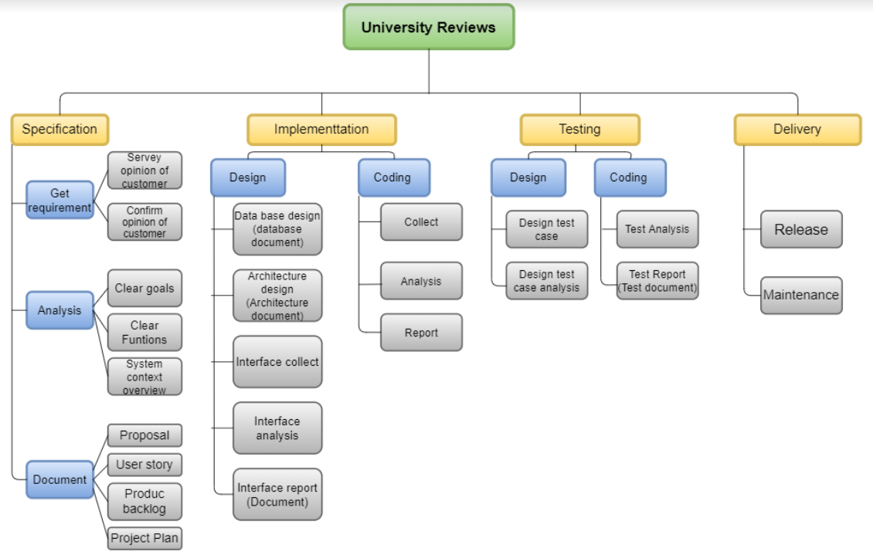

1. Deliverables

Table 10: Deliverables

|  |  |  |  |
| --- | --- | --- | --- |
| **No.** | **Document** | **Deadline** | **Responsible** |
| 1 | Proposal Document. | 18 –Aug– 2020 | All members |
| 2 | Project Plan Document | 27 –Aug– 2020 | Thien |
| 3 | User Story Document | 28 –Aug– 2020 | Sang |
| 4 | Database Design Document. | 24 –Nov– 2020 | Toi |
| 5 | Product Backlog Document. | 16 –Sep– 2020 | Toi |
| 6 | Sprint Backlog Document. | 05 –Oct– 2020 | Thien |
| 7 | SRS Document | 15 –Oct– 2020 | Thuong |
| 8 | User Interface Design Document. | 15 –Oct– 2020 | Sang |
| 9 | Architecture Design Document. | 25 –Oct– 2020 | Thuong |
| 10 | Test Plan Document. | 15 –Nov– 2020 | Sang |
| **No.** | **Product** | **Deadline** | **Responsible** |
| 11 | URs | 06 –Dec– 2020 | Toi |